# Student Registration Form – using Laravel

Laravel PHP follows MVC architecture that is Model, View, Controller.   
Here are their functionalities:  
  
Model:  
Handles the business logic and database crud operations.  
  
View:  
Handles the user interface.  
  
Controller:  
Handles the HTTP request to process and return a response.  
  
Router:  
Defines routes to connect URLS to views or controllers.

Tech Stack:

* Laravel PHP
* HTML
* Tailwind
* Javascript
* Blade
* SQLite

File Structure and their functions   
MODELS:  
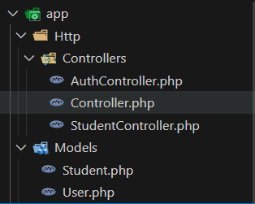  
Functions:  
 • Student.php defines the fillable fields and getting student   
 by rollno function.  
 • User.php defines the fillable fields, hidden fields and getKey   
 function to get the user by id (primary key).  
  
CONTROLLERS:  
  
Functions:  
 • AuthController.php defines the crud operations related to  
 Authentication like register, login, logout, refresh.   
 • StudentController.php defines the crud operations   
 for the Student Model. It contains apis that are protected   
 with middleware for security. These are restful apis that   
 return a json response.  
  
  
  
VIEWS:  
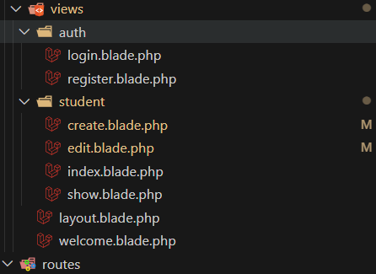  
Functions:  
 • layout contains the top navigation bar which consists of  
 dashboard, form, (sign in signout) / (username logout) ->   
 depending on if the user is logged in or not.   
 • welcome contains a welcome message and link to sign in   
 and register.  
  
 • auth.login shows the login view collects user data via a form   
 and sends an HTTP POST request to AuthController to login  
 the user  
 • auth.register shows the register view collects user data via a   
 form and sends an HTTP POST request to AuthController to   
 register the user  
   
  
  
  
• student.create shows the create user view and collects student data via a form and sends student detail as a HTTP

POST request to StudentController to the data in the database.  
• student.edit shows the edit user view and collects student data via a form and sends student detail as a HTTP POST

request to StudentController to the data in the database.  
• student.index sends a HTTP GET request to StudentController to get all the student datas from the database and renders it.

• student.show sends a HTTP GET request to StudentController to get the logged in student’s data from the database and   
 renders it.

ROUTES:  
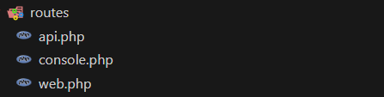  
Functions:  
 • api contains the mapping the url to the appropriate model   
 involving HTTP requests and these routes are protected   
 through a middleware using JWT tokens.   
 • web contains the mapping the url to the appropriate model   
 involving HTTP requests.  
  
User Experience

Initially user will be in the welcome page:  
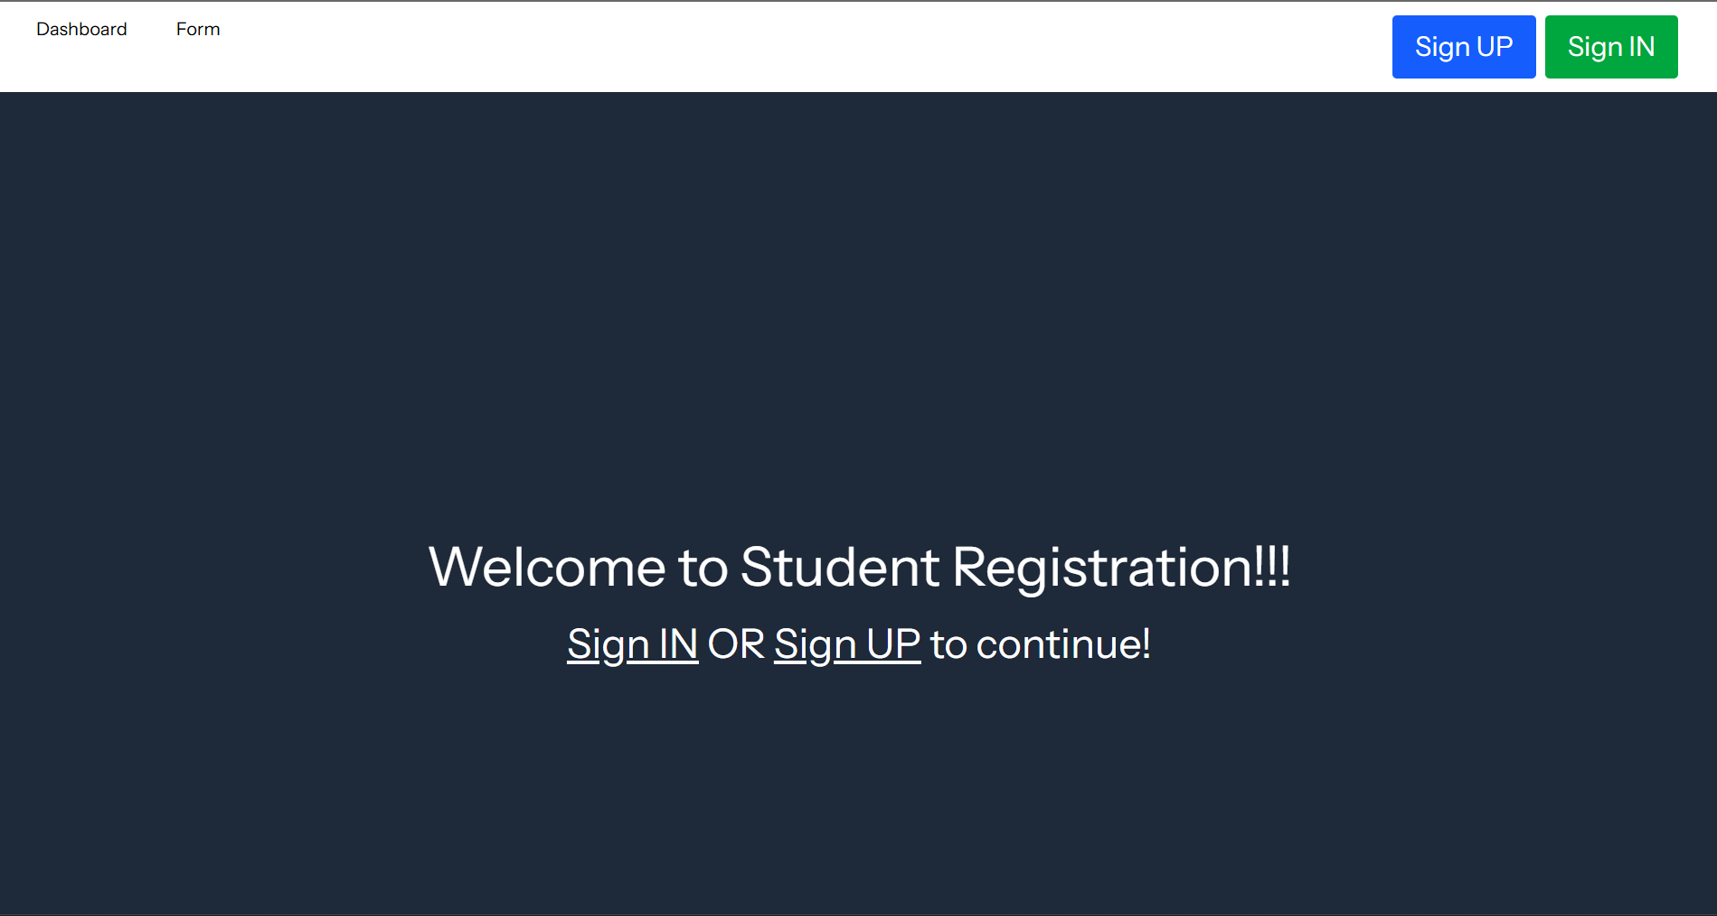  
  
Then the user can either sign in or sign up. I am signing up a new user:

On clicking the Sign UP button the Route redirect user by performing a HTTP GET request which fetches the register view

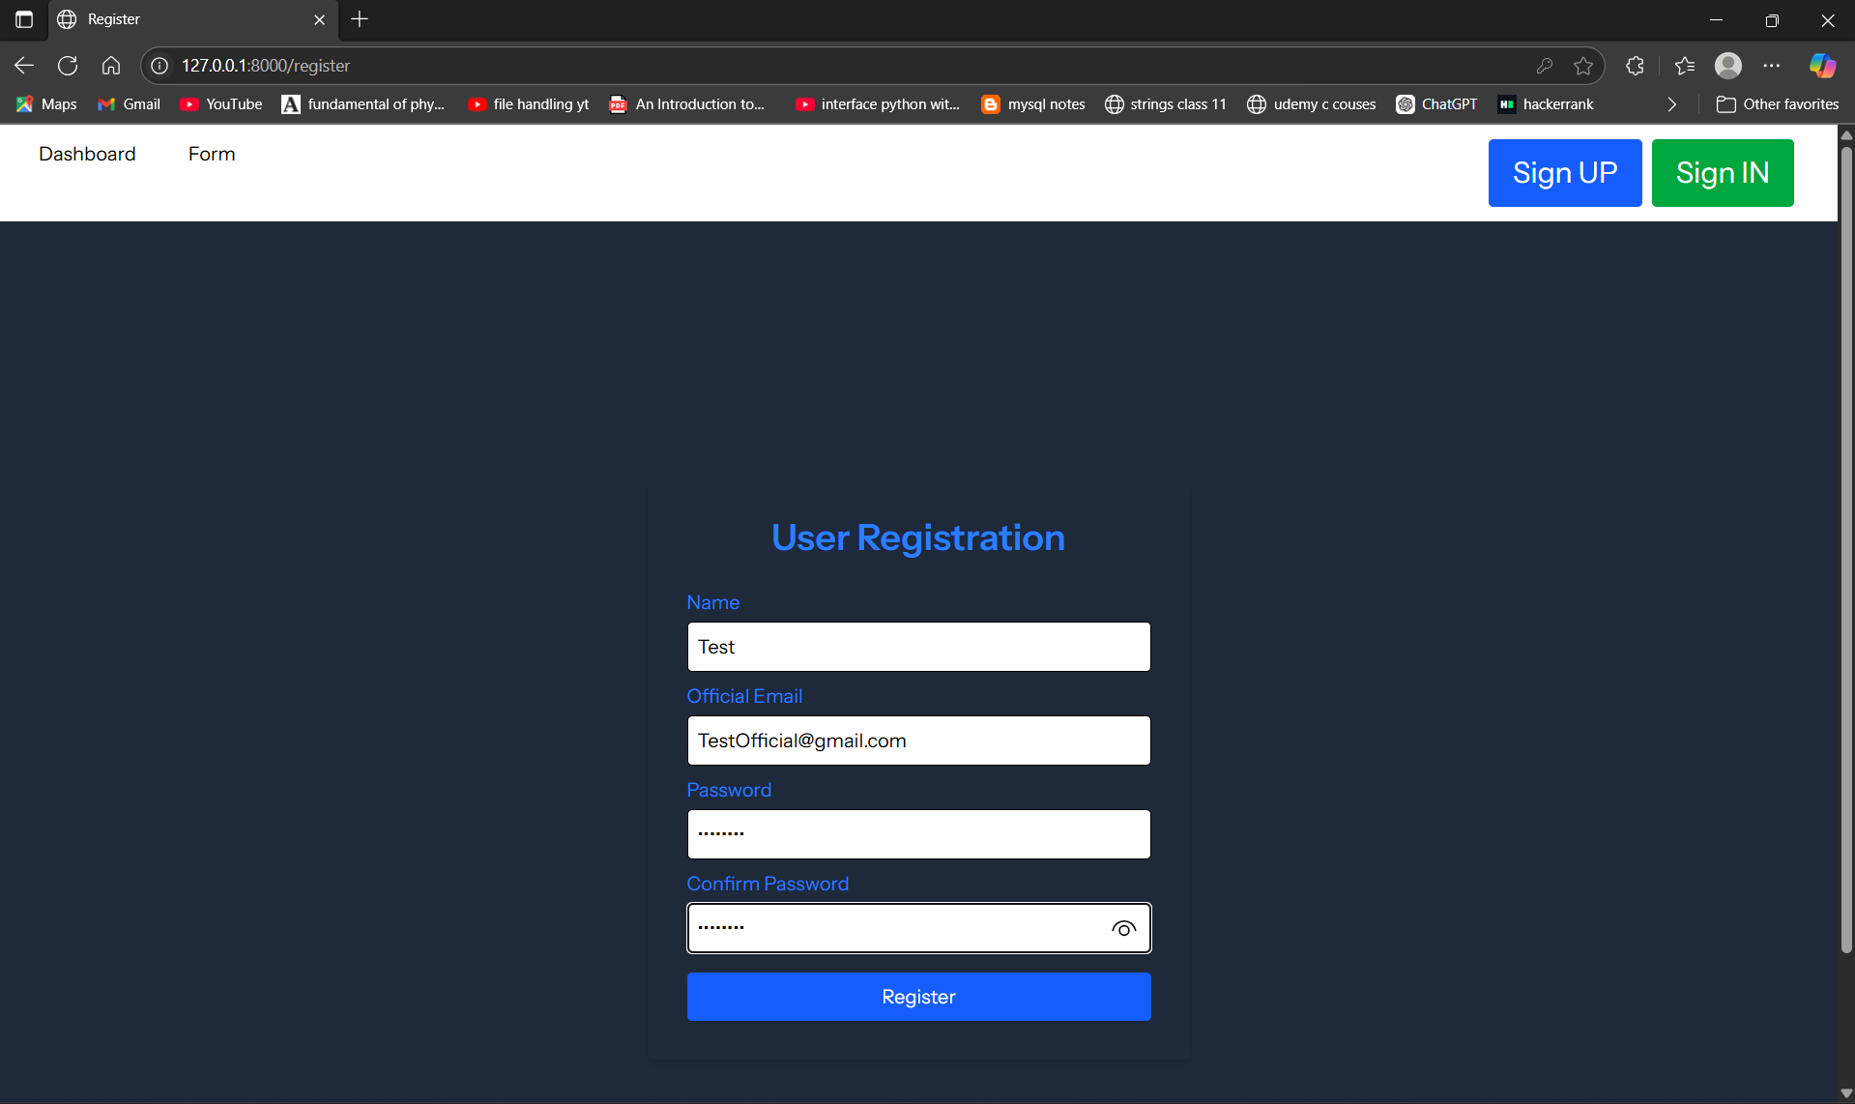  
Now after clicking register a HTTP POST will be made by the routes which triggers an api in the AuthController which creates a row in the database containing these details:

  
and it will prompt:  
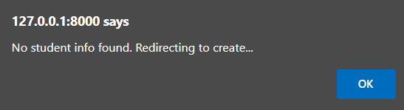  
If I click ok the route makes a HTTP GET request to get the create view:  
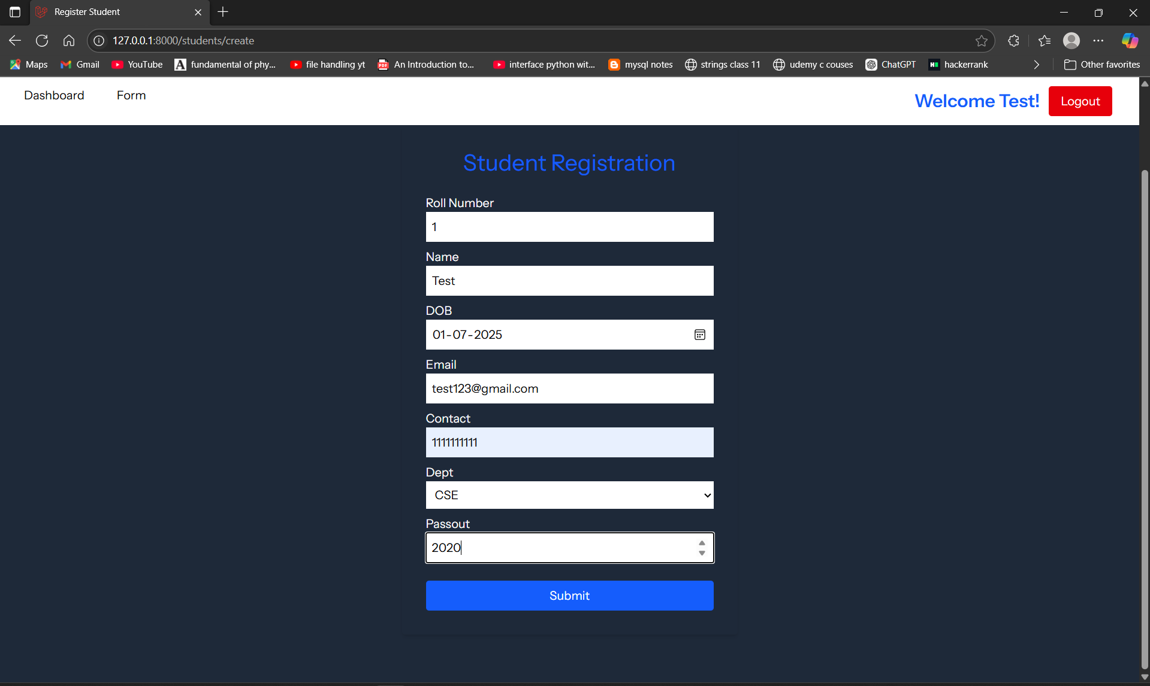  
After clicking submit a HTTP POST request is made by the routes to AuthController to create the student and add it to the database and then a HTTP GET request is made by the routes to get the view to show the newly created student.

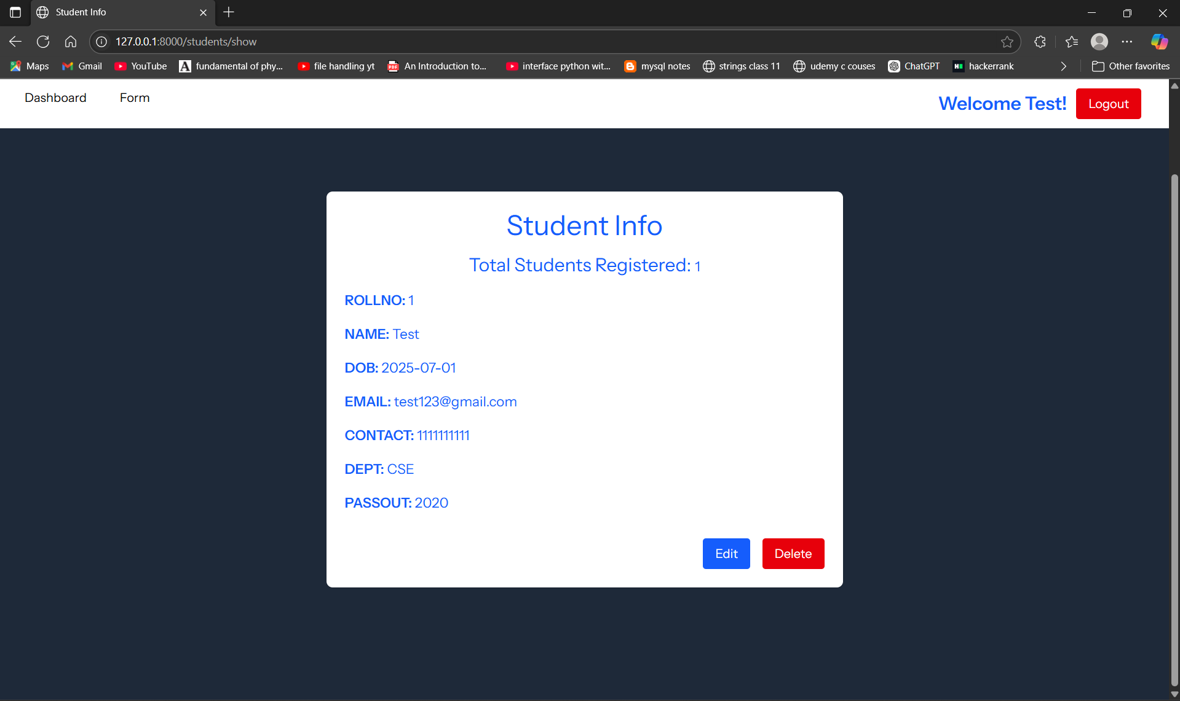  
It also created a new row in the table:

  
I want to edit this now so after clicking edit the router makes a HTTP GET request to get the edit view which renders the edit page for the user:  
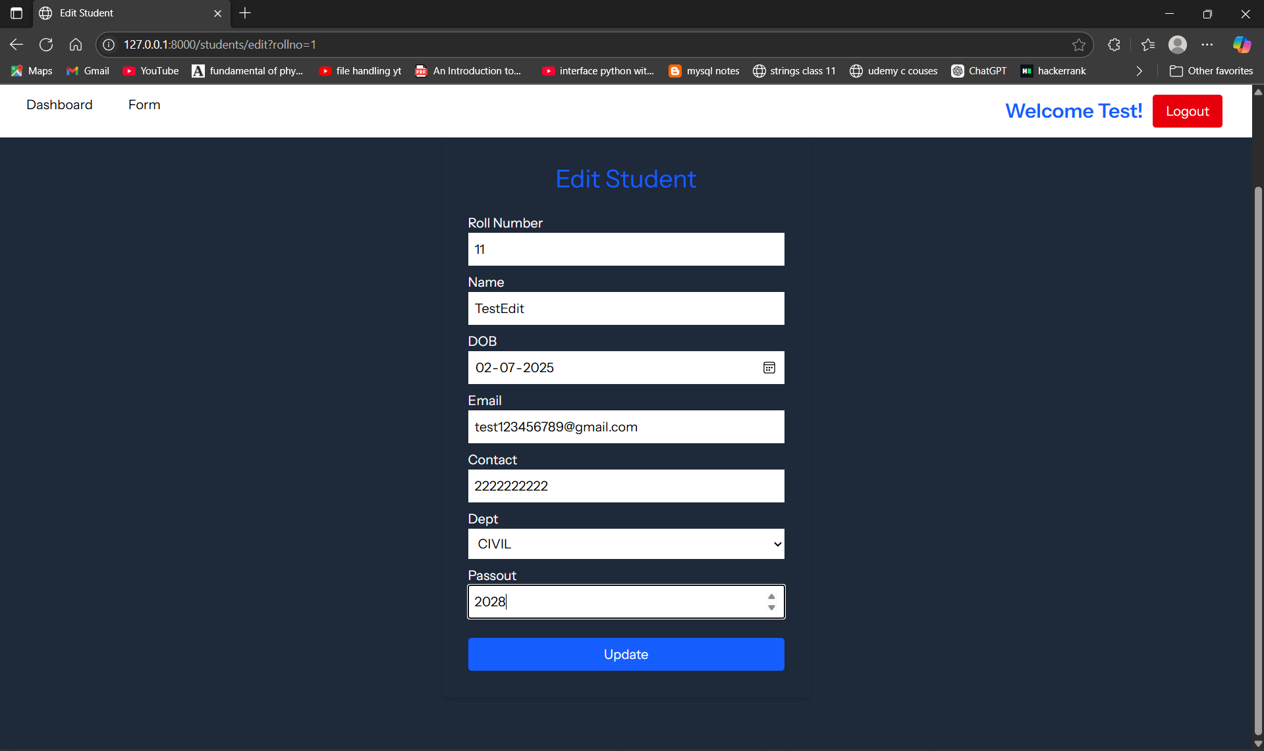  
After clicking Update the routes make a HTTP POST request to the it takes me to the show page:

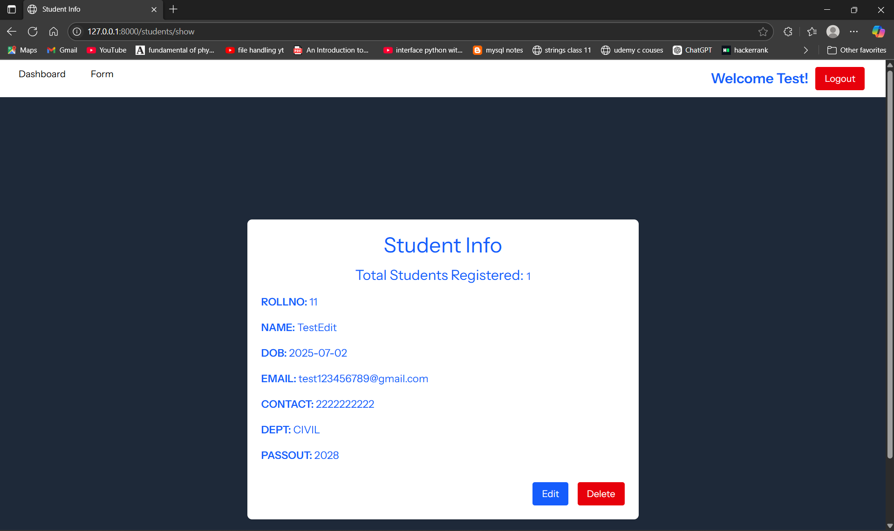

We can notice the form is edited  
I want the form to be deleted, so on clicking delete it will prompt me:

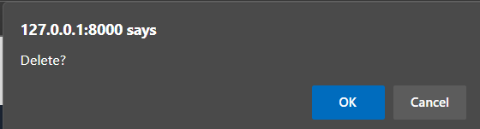

After clicking ok

It deletes the row from the table:



And redirects to the create page as no form is there to show

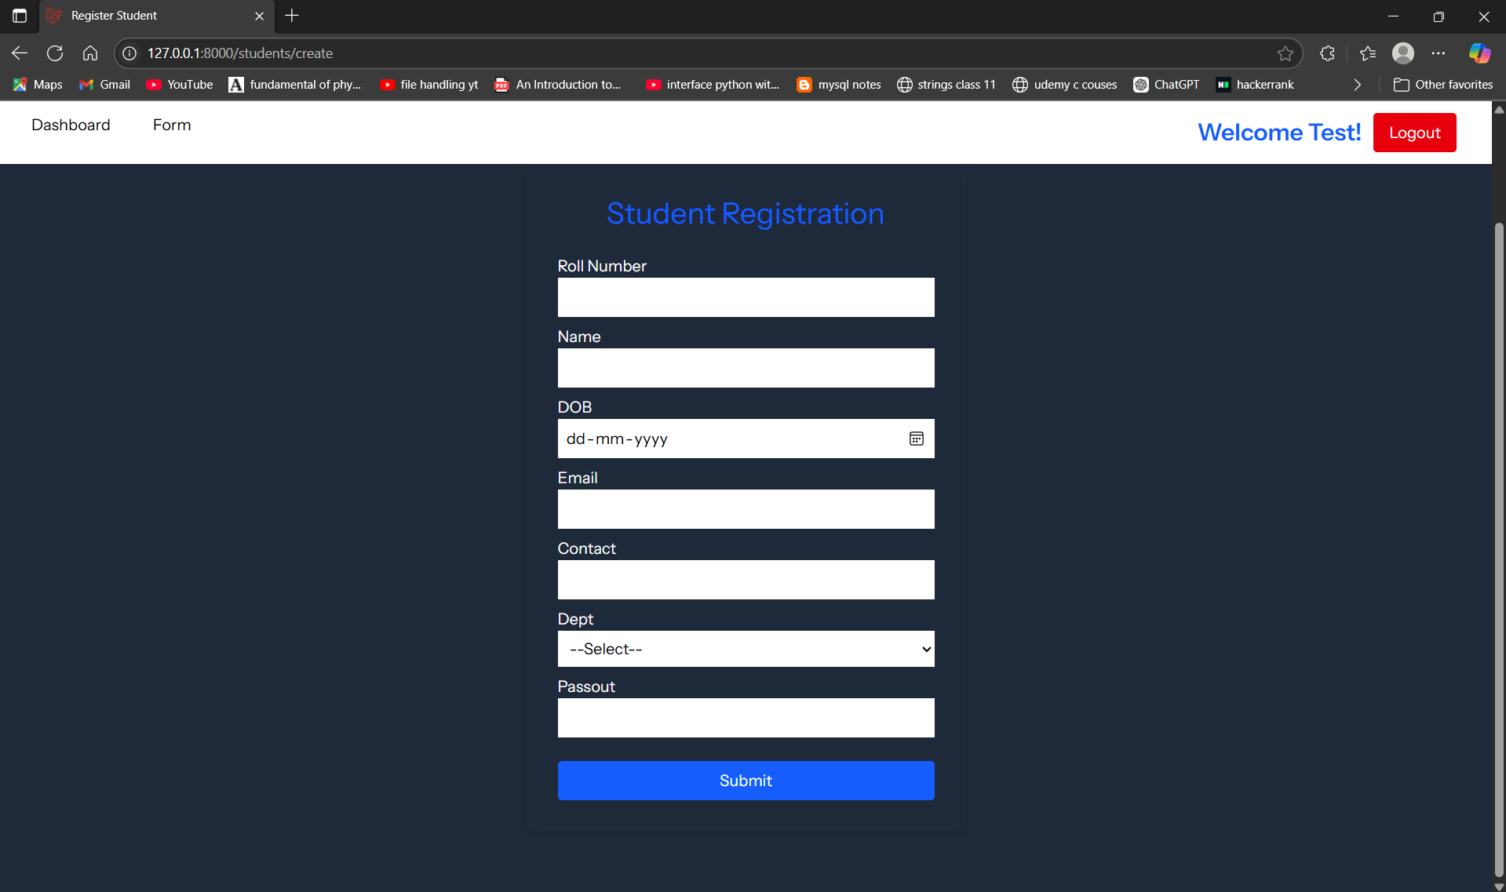  
Now if I click Logout it takes me to the welcome page

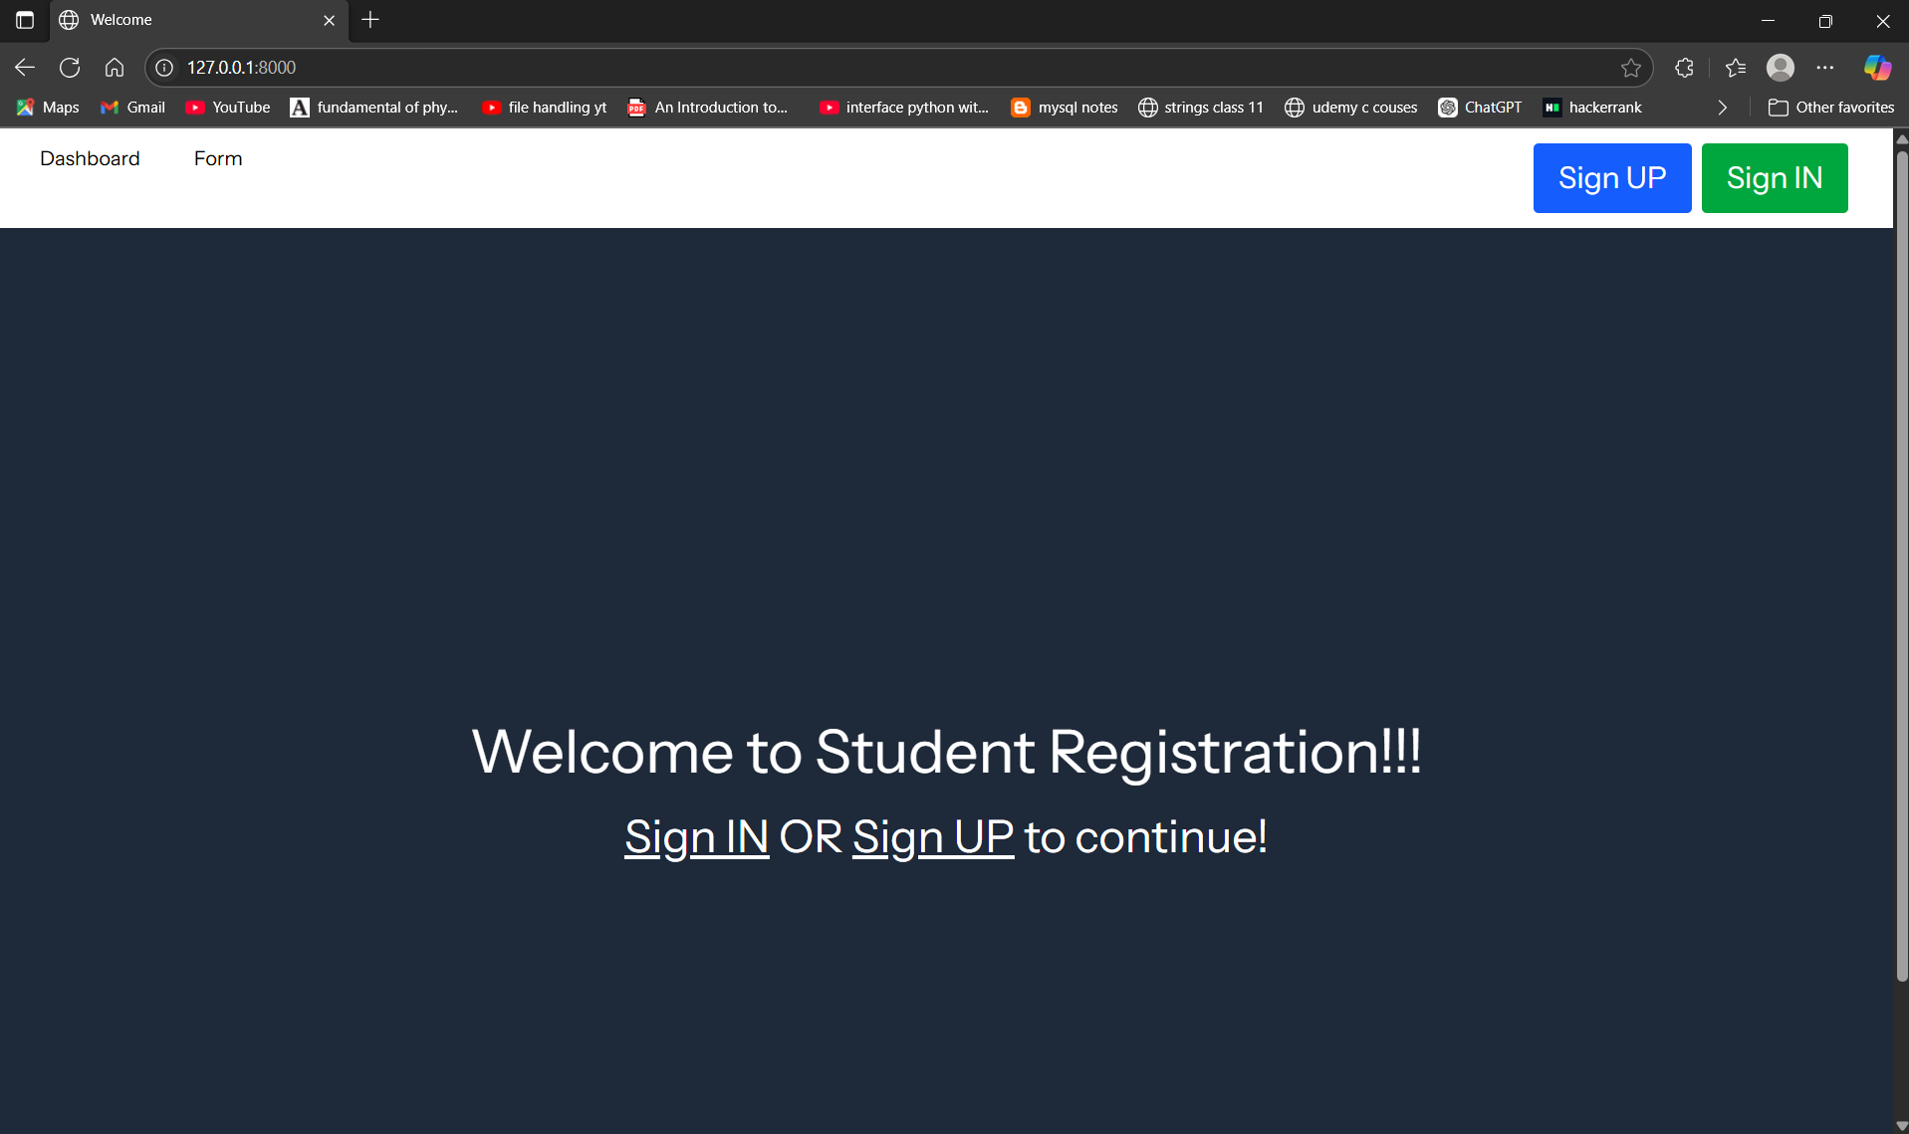

And we can notice the sign in and sign up options are shown because the user is not authenticated.

Now let us see what happens if I login as [TestOfficial@gmail.com](mailto:TestOfficial@gmail.com):

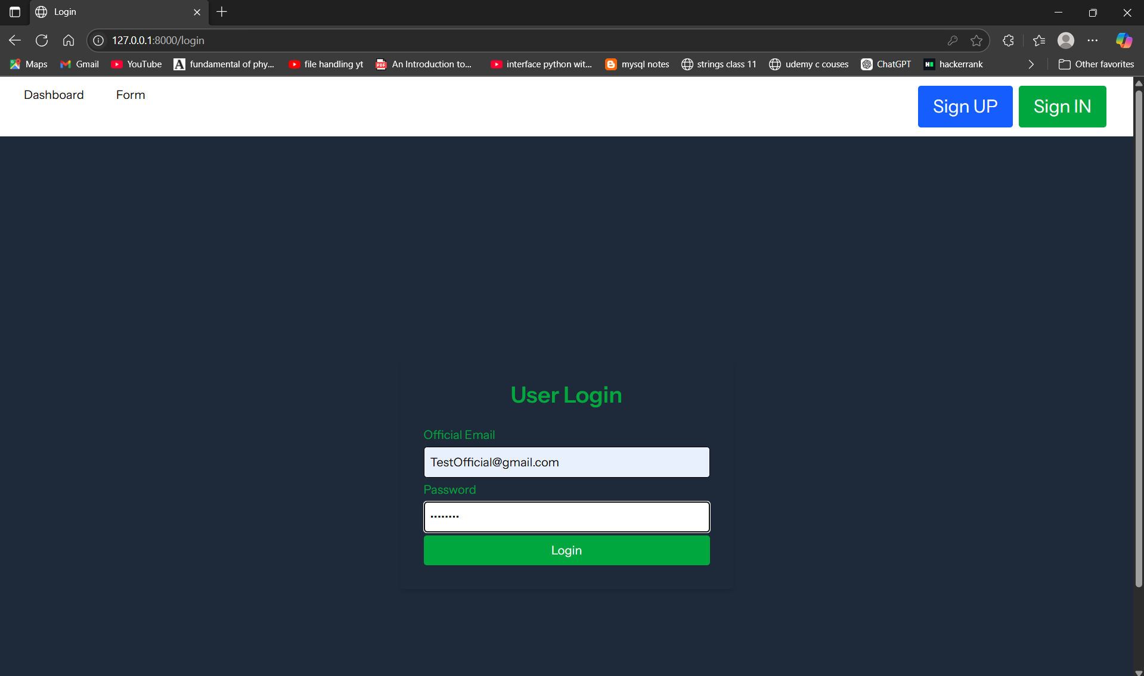

After clicking Login it takes me to the create page as student didn’t exist (we deleted the student earlier)  
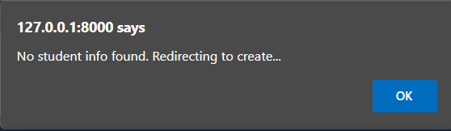

After clicking OK

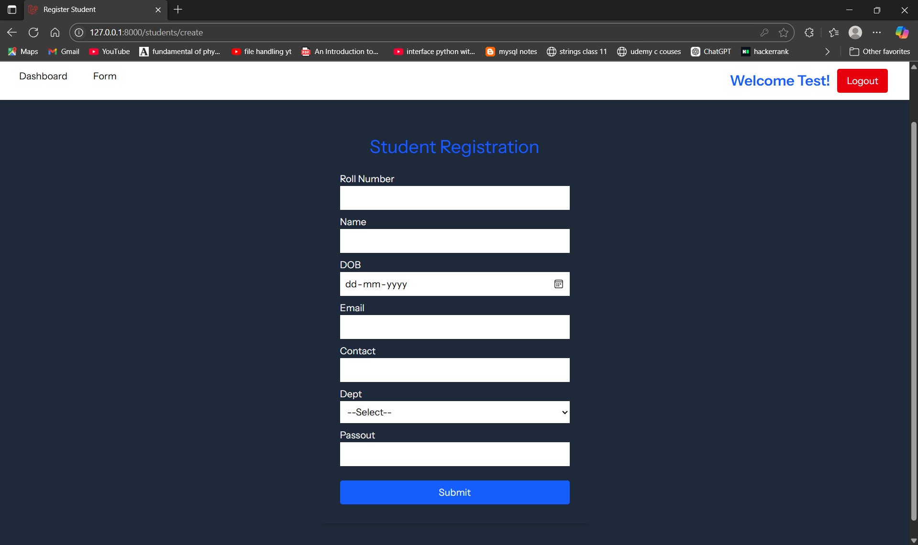

So I will create a student and Logout and relogin

Now that a student is registered it directly took me to the show page directly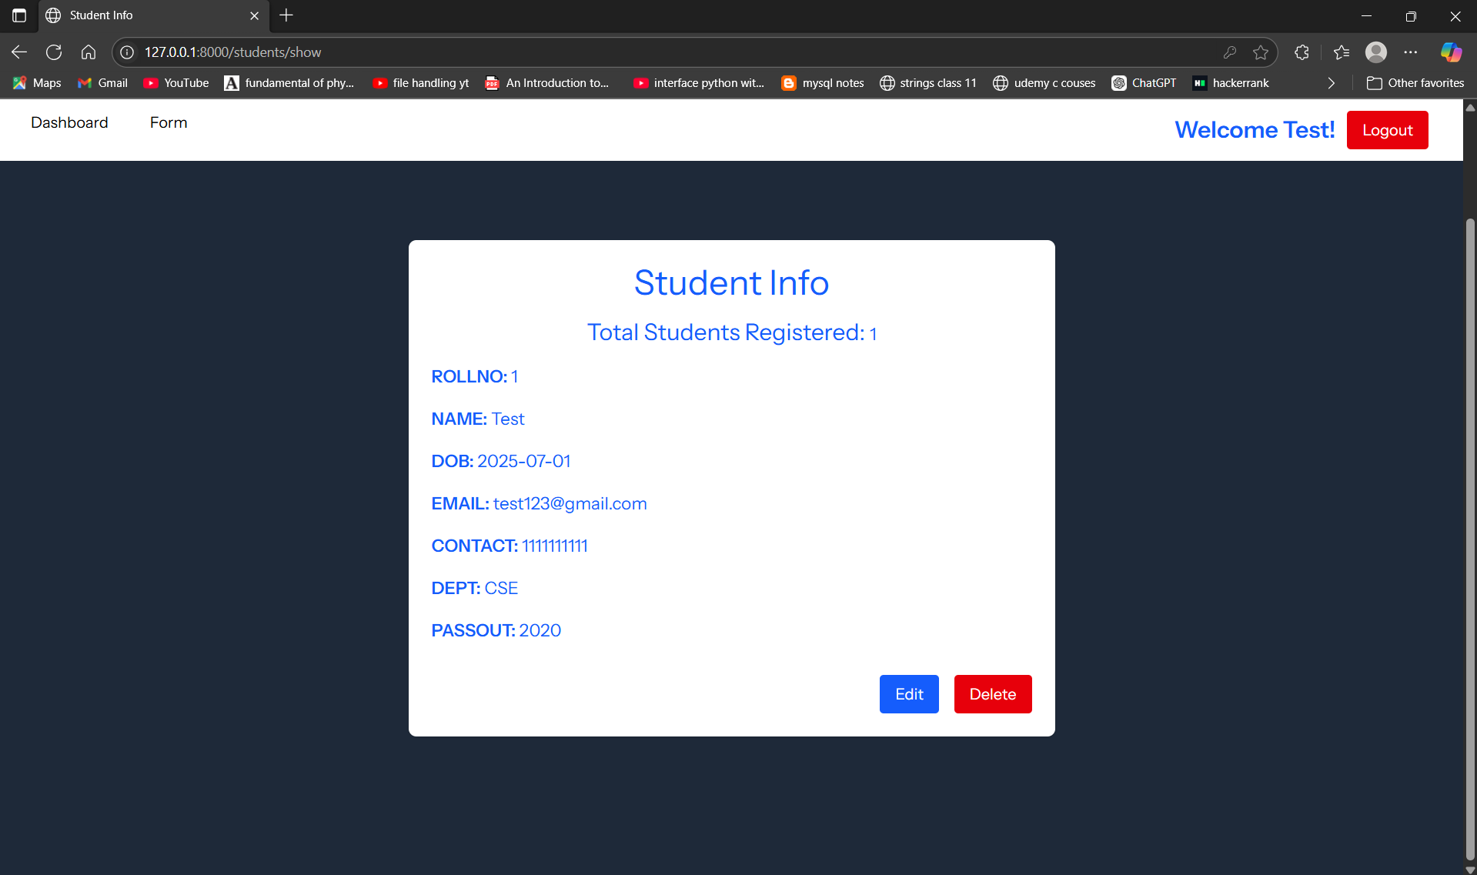

Few Notes about authentication:

JWT auth is used in this project which creates a token in the client side instead of server side which is more scalable as the server don’t get flooded with tokens from user

And auth:api middleware is configured to check for jwt tokens for protected apis inside the api.php folder

Thank you for reviewing this project.

Github repo link to get the source code :  
https://github.com/Hariking967/StudentRegFormJWT